Creation: Ao and Po (Polynesian)

The entire universe is dual in nature. There is Ao: light, day, sky, the male principle. Its opposite is Po: darkness, night, the earth, the female principle. The darkness of Po should not be confused with the use of the word darkness to mean ‘’evil’’. The darkness of Po is warm and nurturing like the earth or the womb. In the hawaiian Creation story, the Kumulipo, or ‘’Genealogy of All Things,’’ there was only a great watery Chaos at the beginning until Ku, the Creator, began to chant, separating Ao from Po.
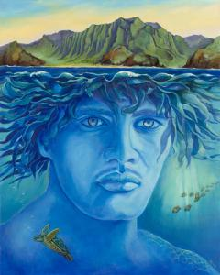
Of course this could be translated a number of ways, such as ‘’things of darkness give birth to darkness’’ and ‘’things of light give birth to light’’ But the great act of Creation was the work of separating Ao from Po, making the world possible and separating day from night. Ku drew out Kanaloa, the squid, later the god of the sea. Then Ku drew out Kane (Tane, in New Zealand). Perhaps kane was born out of the union of Ku, as Father Sky, with Hina, as Mother earth. Kane means ‘’man.’’ Kane had intercourse with a number of beings and thus produced grass, streams, and reptiles. But he wanted a child in his own image. So he took some soft red clay from Hawaiki, the mythical homeland of the Polynesians, and fashioned Hine-hau-ona, or ‘’earth=formed woman.’’ since dawn is the point when night meets day. But Kane became wicked and took Hine-titama, his own daughter, as a wife, concealing from her that he was her father.

This was a basic violation of the laws of nature, the great kapu, or taboo, against incest. Hina knew that Kane’s desires were wrong. When hine-titama learned that Kane was also her father, she ran screaming into her mother’s domain, the Po world of the dead. Hine-titama cried, ‘’You have broken the umbilical cord of the world!’’ So it was decreed that kane could not touch his daughter. Hine-titama and her mother became co-rulers of the dead in the Po world beneath the earth. Kane was thenceforth confined to the Ao world above ground.

Because of Kane’s crime, his children reside here on earth during their lifetimes. But when they die, they go to live with their mother, who as mother earth forms a protective barrier between the wicked Kane and his children below ground in the Po world. We also know Po in life as the creative world night, a place of dreams, lovemaking, and the appearance of spirits.

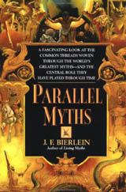
Story taken from (and slightly altered):
Bierlein, J. F. Parallel Myths. New York: Ballantine, 1994.

