Creation: Norse

Long ago there was no heaven above nor an earth beneath, only a vast bottomless deep shrouded in an atmosphere of mist. Somewhere in the middle of the abyss was a fountain from which twelve rivers flowed out like the spokes of a wheel. As the rivers flowed, they froze.
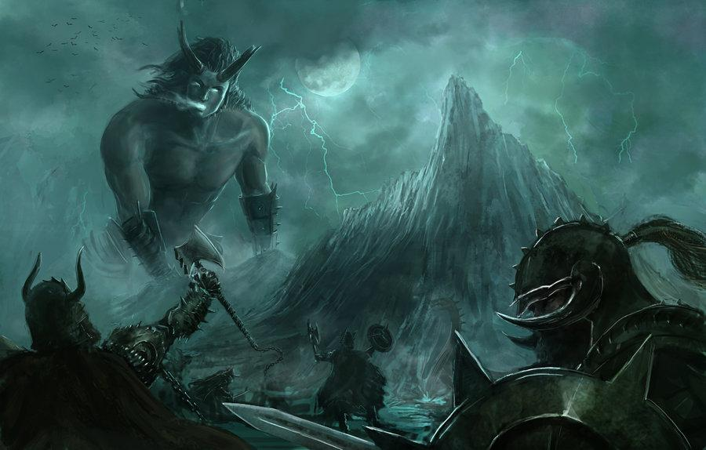
South of the world of mist, there was a world of light. Once a warm breeze blew out from the south and began to melt the ice. The contact of the warm air and the cold created clouds. These clouds congealed to form the frost giant, Ymir, and his cow, Audhumbla, whose milk nourished the giant. As she licked and licked, she exposed a man buried in the ice. On the first day, his hair was exposed; on the second day, one could see his whole head and shoulders. By the third day, one could see his whole body was free of the ice. This was the first god, the father of Odin, Vili, and Ve.

These three young gods slow Ymir and his salty blood flowed out to make the seas. The bones of Ymir formed the mountains and his flesh formed the earth. From his hair sprang up all manners of plants. Among these were the ash tree and the elm. From the ash tree, Odin fashioned a man and from the elm, a woman. From Odin himself, the humans received life and a soul. Vili gave them reason and motion, while Ve gave them speech and motion.

Odin organized the world, separating the darkness from the light, creating night and day. Odin fashioned Asgard, home of the gods. The universe is supported by yggdrasil, a mighty ash tree. One of her roots touches Asgard, another Midgard, and a third lies underground, where the souls of the dead dwell under the eye of Odin’s sister, Hel.

Ymir the giant was not completely killed, part of his body is still alive and sleeps at the foot of the great ash tree Yggdrasil. When his body stirs, the earth quakes.

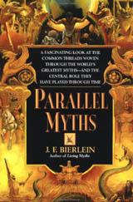
Story taken from:
Bierlein, J. F. Parallel Myths. New York: Ballantine, 1994.

