Creation: Japan

In the beginning there was nothing but a vast oily sea of Chaos that contained a mix of all the elements. There were three spirits or ‘’kami’’ in heaven who looked out over this sea and decided that a world ought to be created. The spirits produced many gods and goddesses, including Izanagi and Izanami. Izanagi was entrusted with a magic jeweled spear for his work.

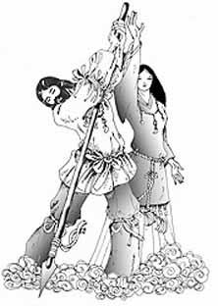
Izanagi and Izanami descended from heaven and Izanagi stirred the spear around in the sea. When he pulled it out of the Chaos, some drops congealed on the tip of the spear. Then the drops fell back into the sea, where they formed an island. Together they began to conceive many wonderful things.

The first thing they conceived was a disappointment--the leech. They placed it in a reed basket and cast it adrift. To this day, the leech still likes to live among the reeds. Then Izanami give birth to an island--the Foam Island, which was useless. Then Izanami gave birth to the fire Spirit, which burned her body very badly, causing her to become seriously ill. While she was ill, her vomit became the Metal Mountain prince and princess, the source of all mines. Her feces became the clay, and her urine, the Fresh Water spirit.

But Izanami was dying. Izanagi wept bitter tears as she descended into the land of the Night. He begged her not to say there, but she replied that she could not leave as she had eaten some of the food there. Izanagi then went out into the Land of Night to fetch his wife. But when he arrived, he was horrified--she had begun to decay. When Izanagi finally took a good look at her, he was so horrified he began to run away. Izanami sent the Ugly Night Spirit to retrieve him.

Izanagi continued to run in terror and disgust, leaving the horrible Land of Night behind him. As he was running away, he cast down the comb from the left side of his hair, and it became bamboo shots. When the Ugly Night Spirit stopped to eat grapes and bamboo shoots, Izanagi was able to escape toward the upper world.

Izanami was now more determined than ever to get her husband back. She now sent eight thunder-spirits and all the warriors of the Land of Night after him. But Izanagi outran them all. Out of breath, he stopped to rest beneath a peach tree at the border between the Land of Night and the upper world. When the forces sent by Izanami approached, Izanagi threw peaches at them. To his amazement, they ran in terror; to this day it is known that peaches dispel evil spirits.

Izanami was now furious. She called to her husband ‘’If you continue to flee, I will strangle one thousand of the people of earth every day.’’ Izanagi replied that if she did that, he would cause one thousand new people to be born every day. Thus, death entered the world but the human race still survives. Izanagi then took a great rock and sealed off the Land of Night. Izanami’s spirit remains there, ruling over the dead.

Izanagi was tired after his flight from the terrible land and refreshed himself by bathing in a stream. He needed to wash away the defilements of the terrible land of the dead and, as he did, gods and goddesses were produced. As he washed his left eye, Amaterasu Omikami the sun-goddess and ancestress of the emperor, was born. As he washed his right eye, it became Tsukiyomi-no-Mikoto, the moon. When he washed his nose, Susano-O, the storm god, was born.

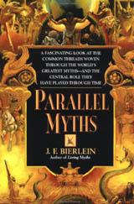
Story taken from (and slightly altered):
Bierlein, J. F. Parallel Myths. New York: Ballantine, 1994.

