Creation: Chinese Version

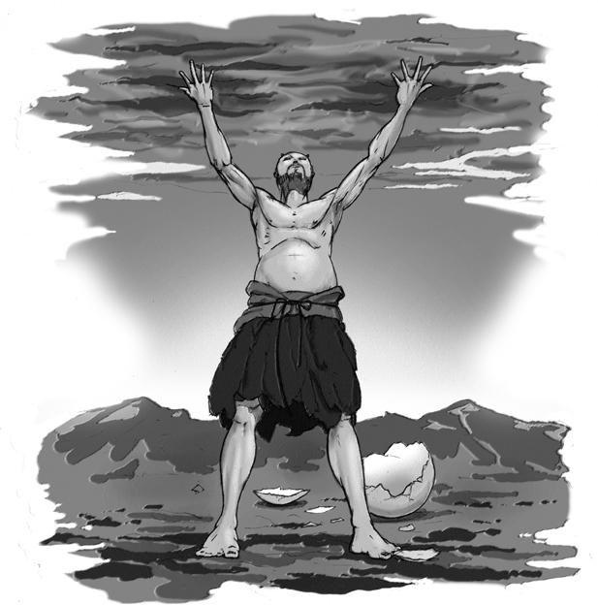

Chaos was like a hen’s egg. The parts of the egg separated into the Yin and the Yang, the male and female essences of all living things. The lighter parts rose to the top, becoming sky and heaven, while the heavier parts sank to become the earth and sea. Out of this egg also came the giant Pangu.

Pangu grew at the rate of ten feet per day for eighteen thousand years until his height spanned the distance between earth and heaven. Then pangu died. Upon his death, his body decomposed and his stomach formed the central mountains; his eyes, the sun and the moon; his tears, rivers; his breath, the wind; and his bones, metals and stones. His semen became pearls, and his bone marrow, jade.

Story taken from:
Bierlein, J. F. Parallel Myths. New York: Ballantine, 1994.
