The sea and the wet sand to one side of it; green tropical forest on the other; above it, the slow, tumbling clouds. The clean, round, blinding disk of sun and the blue sky covered and surrounded the small African village, Kumansenu.

A few square mud houses with roofs like helmets were here thatched, and there covered with corrugated zinc, where the prosperity of cocoa and trading had touched the head of the family.

The widow Bola stirred her palm-oil stew and thought of nothing in particular. She chewed a kola nut rhythmically with her strong toothless jaws, and soon unconsciously she was chewing in rhythm with the skipping of Asi, her grandaughter. She looked idly at Asi, as the seven-year-old brought the twisted palm-leaf rope smartly over her head and jumped over it, counting in English each time the rope struck the ground and churned up a little red dust. Bola herself did not understand English well, but she could easily count up to twenty in English, for market purposes. Asi shouted, “Six,” and then said, “Nine, ten.” Bola called out that after six came seven. “And I should know,” she sighed. Although now she was old and her womb and breasts were withered, there was a time when she bore children regularly, every two years. Six times she had borne a boy child and six times they had died. Some had swollen up and with weak, plaintive cries had faded away. Others had shuddered in sudden convulsions, with burning skins, and had rolled up their eyes and died. They had all died; or rather he had died, Bola thought, because she knew it was one child all the time whose spirit had crept up restlessly into her womb to be born and mock her. The sixth time, Musa, the village magician whom time had now transformed into a respectable Muslim, had advised her and her husband to break the bones of the quiet little corpse and mangle it so that it could not come back to torment them alive again. But she had held on to the child and refused to let them mutilate it. Secretly, she had marked it with a sharp pointed stick at the left buttock before it was wrapped in a mat and taken away. When at the seventh time she had borne a son and the purification ceremonies had taken place, she had turned it surreptitiously to see whether the mark was there. It was. She showed it to the old woman who was the midwife and asked her what it was, and she had forced herself to believe that it was an accidental scratch made while the child was being scrubbed with herbs to remove placental blood. But this child had stayed. Meji, he had been called. And he was now thirty years of age and a second-class clerk in government offices in a town ninety miles away. Asi, his daughter, had been left with her to do the things an old woman wanted a small child for: to run and take messages to the neighbors, to fetch a cup of water from the earthenware pot in the kitchen, to sleep with her, and to be fondled.

She threw the washed and squeezed cassava leaves into the red, boiling stew, putting in a finger’s pinch of salt, and then went indoors, carefully stepping over the threshold, to look for the dried red pepper. She found it and then dropped it, leaning against the wall with a little cry. He turned around from the window and looked at her with a twisted half smile of love and sadness. In his short-sleeved, open-necked white shirt and gray gabardine trousers, gold wristwatch, and brown suede shoes, he looked like the picture in African magazines of a handsome clerk who would get to the top because he ate the correct food or regularly took the correct laxative, which was being advertised. His skin was grayish brown and he had a large red handkerchief tied round his neck.

“Meji, God be praised,” Bola cried. “You gave me quite a turn. My heart is weak and I can no longer take surprises. When did you come? How did you come? By truck, by fishing boat? And how did you come into the house? The front door was locked. There are so many thieves nowadays. I’m so glad to see you, so glad,” she mumbled and wept, leaning against his breast.

Meji’s voice was hoarse, and he said, “I’m glad to see you too, Mother,” rubbing her back affectionately.

Asi ran in and cried, “Papa, Papa,” and was rewarded with a lift and a hug.

“Never mind how I came, Mother,” Meji said, laughing. “I’m here, and that’s all that matters.”
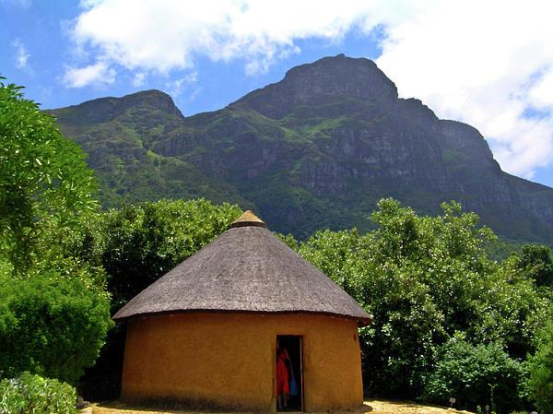
“We must make a feast, we must have a big feast. I must tell the neighbors at once. Asi, run this very minute to Mr. Addai, the catechist, and tell him your papa is home. Then to Mami Gbera to ask her for extra provisions, and to Pa Babole for drummers and musicians . . .”

“Stop,” said Meji, raising his hand. “This is all quite unnecessary. I don’t want to see anyone, no one at all. I wish to rest quietly and completely. No one is to know I’m here.”

Bola looked very crestfallen. She was so proud of Meji and wanted to show him off. The village would never forgive her for concealing such an important visitor. Meji must have sensed this because he held her shoulder comfortingly and said, “They will know soon enough. Let us enjoy each other, all three of us, this time. Life is too short.”

Bola turned to Asi, picked up the packet of pepper, and told her to go and drop a little into the boiling pot outside, taking care not to go too near the fire or play with it. After the child had gone, Bola said to her son, “Are you in trouble? Is it the police?” He shook his head. “No,” he said, “it’s just that I like returning to you. There will always be this bond of love and affection between us, and I don’t wish to share it with others. It is our private affair and that is why I’ve left my daughter with you.” He ended up irrelevantly, “Girls somehow seem to stay with relations longer.”

“And don’t I know it,” said Bola. “But you look pale,” she continued, “and you keep scraping your throat. Are you ill?” She laid her hand on his brow. “And you’re cold, too.”

“It’s the cold, wet wind,” he said, a little harshly. “I’ll go and rest now if you can open and dust my room for me. I’m feeling very tired. Very tired indeed. I’ve traveled very far today, and it has not been an easy journey.”
“Of course, my son, of course,” Bola replied, bustling away hurriedly but happily.

Meji slept all afternoon till evening, and his mother brought his food to his room and, later, took the empty basins away. Then he slept again till morning.

The next day, Saturday, was a busy one, and after further promising Meji that she would tell no one he was about, Bola went off to market. Meji took Asi for a long walk through a deserted path and up into the hills. She was delighted. They climbed high until they could see the village below in front of them, and the sea in the distance, and the boats with their wide white sails. Soon the sun had passed its zenith and was halfway toward the west. Asi had eaten all the food, the dried fish and the flat tapioca pancakes and the oranges. Her father said he wasn’t hungry, and this had made the day perfect for

Asi, who had chattered, eaten, and then played with her father’s fountain pen and other things from his pocket. They soon left for home because he had promised that they would be back before dark; he had carried her down some steep boulders and she had held on to his shoulders because he had said his neck hurt so and she must not touch it. She had said, “Papa, I can see behind you and you haven’t got a shadow. Why?”

He had then turned her around facing the sun. Since she was getting drowsy, she had started asking questions, and her father had joked with her and humored her. “Papa, why has your watch stopped at twelve o’clock?” “Because the world ends at noon.” Asi had chuckled at that. “Papa, why do you wear a scarf always around your neck?” “Because my head would fall off if I didn’t.” She had laughed out loud at that. But soon she had fallen asleep as he bore her homeward.

Just before nightfall, with his mother dressed in her best, they had all three, at her urgent request, gone to his father’s grave, taking a secret route and avoiding the main village. It was a small cemetery, not more than twenty years or so old, started when the Rural Health Department had insisted that no more burials were to take place in the back yard of households. Bola took a bottle of wine and a glass and four split halves of kola, each a half sphere, two red and two white. They reached the graveside and she poured some wine into the glass. Then she spoke to her dead husband softly and caressingly. She had brought his son to see him, she said. This son whom God had given success, to the confusion and discomfiture of their enemies. Here he was, a man with a pensionable clerk’s job and not a poor farmer, a fisherman, or a simple mechanic. All the years of their married life, people had said she was a witch because her children had died young. But this boy of theirs had shown that she was a good woman. Let her husband answer her now, to show that he was listening. She threw the four kola nuts up into the air and they fell onto the grave. Three fell with the flat face upward and one with its flat face downward. She picked them up again and conversed with him once more and threw the kola nuts up again. But still there was an odd one or sometimes two.

They did not fall with all four faces up, or with all four faces down, to show that he was listening and was pleased. She spoke endearingly, she cajoled, she spoke severely. But all to no avail. She then asked Meji to perform. He crouched by the graveside and whispered. Then he threw the kola nuts and they rolled a little, Bola following them eagerly with her sharp old eyes. They all ended up face downward. Meji emptied the glass of wine on the grave and then said that he felt nearer his father at that moment than he had ever done before in his life.

It was sundown, and they all three went back silently home in the short twilight. That night, going outside the house toward her son’s window, she had found, to her sick disappointment, that he had been throwing all the cooked food away out there. She did not mention this when she went to say good night, but she did sniff and say that there was a smell of decay in the room. Meji said that he thought there was a dead rat up in the rafters, and he would clear it away after she had gone to bed.

That night it rained heavily, and sheet lightning turned the darkness into brief silver daylight for one or two seconds at a time. Then the darkness again and the rain. Bola woke soon after midnight and thought she could hear knocking. She went to Meji’s room to ask him to open the door, but he wasn’t there. She thought he had gone out for a while and had been locked out by mistake. She opened the door quickly, holding an oil lamp upward. He stood on the veranda, curiously unwet, and refused to come in.

“I have to go away,” he said hoarsely, coughing.

“Do come in,” she said.

“No,” he said, “I have to go, but I wanted to thank you for giving me a chance.”

“What nonsense is this?” she said. “Come in out of the rain.”

“I did not think I should leave without thanking you.”

The rain fell hard, the door creaked, and the wind whistled.

“Life is sweet, Mother dear, goodbye, and thank you.”

He turned around and started running.

There was a sudden diffuse flash of silent lightning, and she saw that the yard was empty. She went back heavily and fell into a restless sleep. Before she slept, she said to herself that she must see Mr. Addai next morning, Sunday, or better still, Monday, and tell him about all this, in case Meji was in trouble. She hoped Meji would not be annoyed. He was such a good son.

But it was Mr. Addai who came instead, on Sunday afternoon, quiet and grave, and met Bola sitting on an old stool in the veranda, dressing Asi’s hair in tight, thin plaits.

Mr. Addai sat down and, looking away, he said, “The Lord giveth and the Lord taketh away.” Soon half the village was sitting around the veranda and in the yard.

“But I tell you, he was here on Friday and left Sunday morning,” Bola said. “He couldn’t have died on Friday.”

Bola had just recovered from a fainting fit after being told of her son’s death in town. His wife, Asi’s mother, had come with the news, bringing some of his property. She said Meji had died instantly at noon on Friday and had been buried on Saturday at sundown. They would have brought him to Kumansenu for burial. He had always wished that. But they could not do so in time, as bodies did not last more than a day in the hot season, and there were no trucks available for hire.

“He was here, he was here,” Bola said, rubbing her forehead and weeping.

Asi sat by quietly. Mr. Addai said comfortingly, “Hush, hush, he couldn’t have been, because no one in the village saw him.”

“He said we were to tell no one,” Bola said.

The crowd smiled above Bola’s head and shook their heads. “Poor woman,” someone said, “she is beside herself with grief.”

“He died on Friday,” Mrs. Meji repeated, crying. “He was in the office and he pulled up the window to look out and call the messenger. Then the sash broke. The window fell, broke his neck, and the sharp edge almost cut his head off; they say he died at once.”

“My papa had a scarf around his neck,” Asi shouted suddenly.

“Hush,” said the crowd.

Mrs. Meji dipped her hand into her bosom and produced a small gold locket and put it around Asi’s neck, to quiet her.

“Your papa had this made last week for your Christmas present. You may as well have it now.”
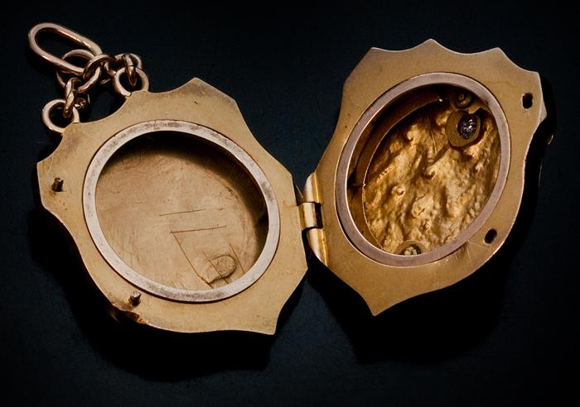
Asi played with it and pulled it this way and that.
“Be careful, child,” Mr. Addai said, “it is your father’s last gift.”

“I was trying to remember how he showed me yesterday to open it,” Asi said.

“You have never seen it before,” Mrs. Meji said sharply, trembling with fear mingled with anger.

She took the locket and tried to open it.
“Let me have it,” said the village goldsmith, and he tried whispering magic words of incantation. Then he said, defeated, “It must be poor-quality gold; it has rusted. I need tools to open it.”
“I remember now,” Asi said in the flat, complacent voice of childhood.
The crowd gathered around quietly, and the setting sun glinted on the soft red African gold of the dangling trinket. The goldsmith handed the locket over to Asi and asked in a loud whisper, “How did he open it?”

“Like so,” Asi said and pressed a secret catch. It flew open and she spelled out gravely the word inside, “A-S-I.”

The silence continued.

“His neck, poor boy,” Bola said a little wildly. “That is why he could not eat the lovely meals I cooked for him.”

Mr. Addai announced a service of intercession after vespers that evening. The crowd began to leave quietly.

Musa, the magician, was one of the last to leave. He was now very old and bent. In times of grave calamity, it was known that even Mr. Addai did not raise objection to his being consulted.

He bent over further and whispered in Bola’s ear, “You should have had his bones broken and mangled thirty-one years ago when he went for the sixth time, and then he would not have come back to mock you all these years by pretending to be alive. I told you so. But you women are naughty and stubborn.”

Bola stood up, her black face held high, her eyes terrible with maternal rage and pride.

“I am glad I did not,” she said, “and that is why he came back specially to thank me before he went for good.”

She clutched Asi to her. “I am glad I gave him the opportunity to come back, for life is sweet. I do not expect you to understand why I did so. After all, you are only a man.”

